LOCAL AUTHOR, DIANNE HARDMAN BOOK SIGNING
Hosted by Terry Miller, By the Sea Art.

SATURDAY APRIL 1 - 11:00 - 4:00 P. M.

Repeat Junction Vintage Shops at “The Red Barn”
4340 Big Barn Drive, Little River, SC

*Novels, Mask of Lies and Death Knows No Silence will be available for sale on day of signing - $12.95 each… Preferred Payment – Cash or Check. A donation from the sale of every book will be made to the North Strand Housing Shelter.

*Love and Forgiveness: Reflections from the Heart is available in eBook format only. For a free sample reading and purchase go to: Dianne Hardman@ Amazon.com

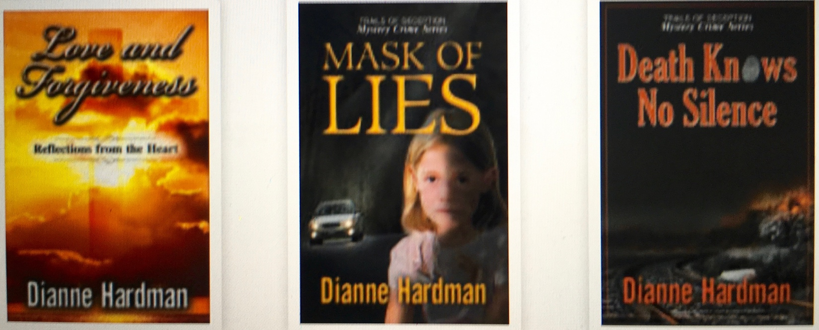
A donation from the sale of every book will be made to the North Strand Housing Shelter.

A donation from the sale of every book will be made to the North Strand Housing Shelter.

A donation from the sale of every book will be made to the North Strand Housing Shelter.

A donation from the sale of every book will be made to the North Strand Housing Shelter.

A donation from the sale of every book will be made to the North Strand Housing Shelter.

A donation from the sale of every book will be made to the North Strand Housing Shelter.

A donation from the sale of every book will be made to the North Strand Housing Shelter.

A donation from the sale of every book will be made to the North Strand Housing Shelter.

A donation from the sale of every book will be made to the North Strand Housing Shelter.

A donation from the sale of every book will be made to the North Strand Housing Shelter.

